Fusion Fuckery Rulebook v4.4
Reality is FUCKED fractured.
A massive multiversal collapse kicked off by a bunch of Reactor Meltdowns turned reality into total chaos. Angels and Blood Demons are real now. Goblins are stealing my fucking gold and some fuck ass dinosaurs strolled out of the past, and for some reason Gregg and his extended family are here too... What the fuck, Gregg?

1. The Golden Rules
When anything in this book seems to clash, these three settle it.
- The card wins. If a card's text contradicts this rulebook, do what the card says.
- Your cards, your job. You remember and trigger your own cards' effects (section 16).
- Newest first. When effects pile up, the last one played resolves first (section 11).

2. How to win
Each player starts with 30 PHP (Player Health Points). Get your opponent to 0 PHP and you win.
Your PHP drops when:
- an enemy creature hits you directly (section 13)
- a card effect deals you damage or makes you lose PHP
- you pay PHP for your own cards. You can pay yourself to 0, and then you lose. Count carefully.
- you can't draw. Running out of cards doesn't knock you out: each time you'd draw from an empty deck, you lose 5 PHP instead.
If both players hit 0 PHP at the same time, the game is a draw.

3. What you need
- A Main Deck of exactly 30 cards and a Fusion Deck of up to 10 fusions.
- Dice. Dice ATK uses a d2 (a coin works), d4, d6, d8, d10, d12 and d20. Spare dice help track damage.
- Your own coin for coin flips.
- Something both players can see to track PHP, Gold and damage on creatures: dice, paper or a phone.

4. Reading a card
Every card is a tiny contract with reality. The frame colour tells you what it is, so cards don't print their type.
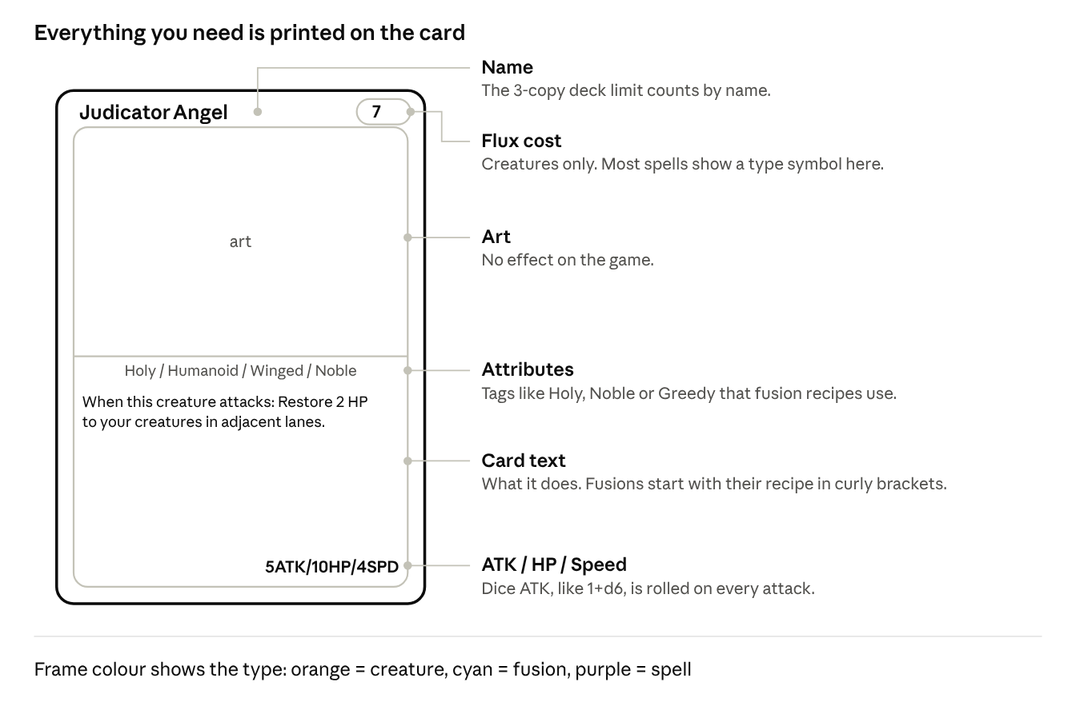
A creature card: 6 parts
- Creatures (orange) show their flux cost in the DNA badge, top right.
- Fusions (cyan) have no flux cost. They come from your Fusion Deck, and their text starts with the recipe in curly brackets, like {Chapel Guard + any Holy creature}.
- Spells (purple) have no stats. A symbol top right shows the spell type; a normal Spell has none (section 11).

5. The play area
Your side mirrors your opponent's, and your 3 lanes line up with theirs.
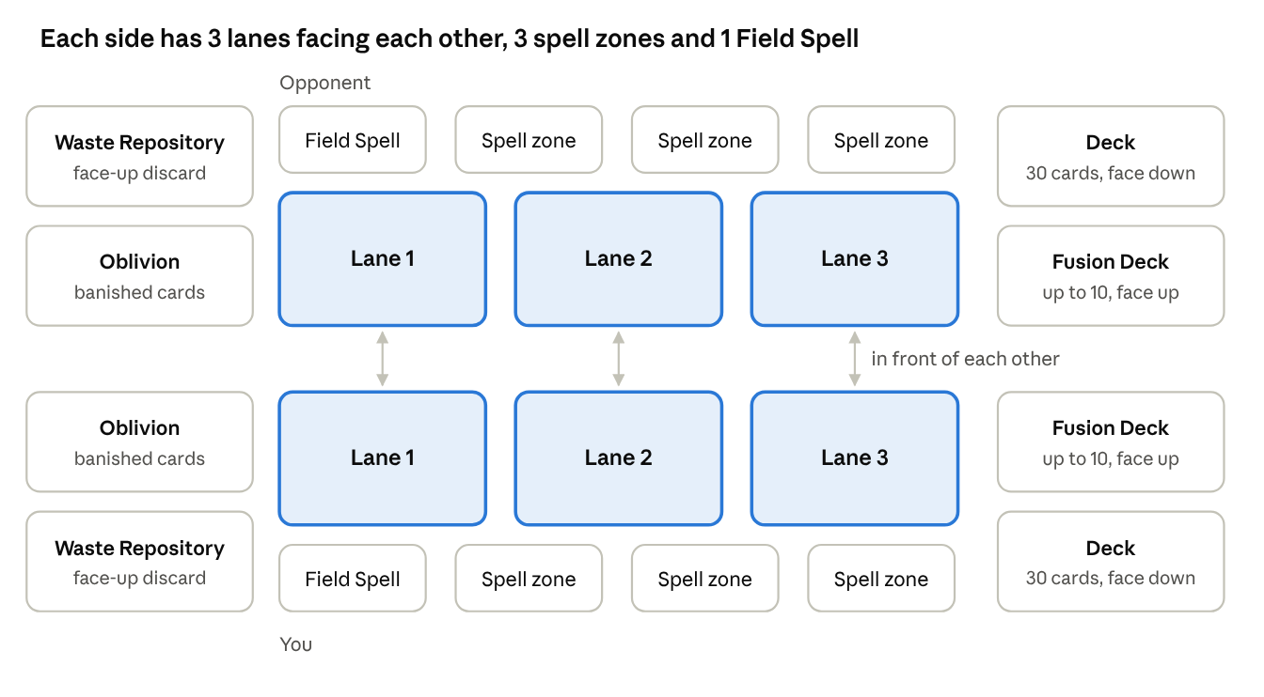
The table: both sides
Zone | What it is
Lanes (3) | Your creature zone. One creature or fusion per lane, so max 3.
Spell zones (3) | Every Spell and Instant is played into an empty spell zone, then leaves when it resolves. Continuous Spells stay. All 3 full = no more spells until one clears.
Field Spell zone (1) | Your Field Spell. 1 per player.
Deck | Your 30-card Main Deck, face down.
Fusion Deck | Your fusions, face up. Anyone can look through it.
Waste Repository | Your face-up discard pile. Used, destroyed and discarded cards go here.
Oblivion | Face up. Banished cards and cards fed to the reactor go here and never come back unless a card says so.

Hidden and public. Your hand and your deck are hidden; everything else is public. Hand size is public too: if your opponent asks how many cards you hold, tell them. Ask before touching the other player's cards.
Where things are.
- In front of: the enemy creature in the same lane, directly across.
- Lanes next to it: the lane or lanes directly left and right. The middle lane has two; the outer lanes have one. Lanes 1 and 3 aren't next to each other.

6. Building a deck
- Main Deck: exactly 30 cards (creatures and spells).
- Fusion Deck: up to 10 fusions. Fusions only go here and don't count toward the 30.
- Copies: max 3 of any card by name, in both decks.
- Mixing: any card can go in any deck.

7. Setting up
- Shuffle your Main Deck and offer it to your opponent to cut.
- Put your Fusion Deck face up next to your field.
- Both players start at 30 PHP and 0 Gold.
- Flip a coin. The winner decides who goes first.
- Each player draws 5 cards.
- Free redraw: if your opening hand has 0 or 1 creatures, you may show it, shuffle it back into your deck and draw 5 new cards. Once per game, and you keep the new hand.
- Mulligan: only if both players agree. Then both shuffle their hands back into their decks and draw 5 new cards, once.
- Start the game.
Going first vs second. The first player skips their first draw and nobody attacks on the first turn of the game. The second player gets +1 flux on their first turn (4 instead of 3).

8. Flux
Flux is what you spend to materialize and fuse creatures. Spells are free.
- You start the game with 3 max flux.
- In your Reactor Phase, except on your first turn, raise your max flux by 1, then refill it.
- Feed the reactor (optional): send 1 card from your hand to Oblivion for +1 flux this turn. Your max flux doesn't change: at 7/7 you feed and have 8/7, and next turn you go to 8/8 as normal. You can feed on your first turn too.
- Skip (optional, instead of feeding): don't raise your max flux this turn (you still refill) and draw 1 extra card. Not on your first turn; you can skip at 10 max flux too. Your normal draw always happens, whatever you choose.
- Max flux caps at 10, on your 8th turn if you never skip.
- Leftover flux doesn't do much: your next Reactor Phase refills you to your max anyway.
- Turns are counted per player: your 3rd turn is the third turn you've taken, no matter who went first.
- A discount can push a cost below 0, and then you gain the difference: a creature that costs -1 flux gives you 1 flux when you play it.
Your turn | 1 | 2 | 3 | 4 | 5 | 6 | 7 | 8+
Max flux | 3 (4 if second) | 4 | 5 | 6 | 7 | 8 | 9 | 10

9. Turn structure
Seven phases, in this order, every turn. Say each one out loud as you go.
# | Phase | What happens
1 | Draw | Draw 1 card. The first player skips this on their first turn.
2 | Reactor | Max flux +1 (not on your first turn), then refill your flux. You may also Feed (a card from your hand to Oblivion: +1 flux this turn) or Skip (no +1 max flux, draw 1 extra card).
3 | Start | Radiance bonuses from your last turn end, then resolve start-of-turn effects.
4 | Main 1 | In any order: materialize creatures, play spells, use effects. One fusion (section 14).
5 | Battle | Attack (section 13). Nobody attacks on the first turn of the game, and creatures that arrived this turn can't attack.
6 | Main 2 | Play spells and use effects. No materializing from your hand and no fusing.
7 | End | End-of-turn effects, then discard down to 8 cards.

10. Materializing creatures
From your hand (natural materialize). Only in Main Phase 1. Pay the creature's flux cost, then put it in any empty lane. You can materialize as many as you can pay for and fit. Some creatures let you pay PHP to reduce their flux cost (Blood Price, section 15).
By an effect (Carrion Duchess, Lord Lazarus and so on). It happens whenever the effect says, even outside Main Phase 1, and you don't pay flux. It still needs an empty lane: no room, no creature.
Either way:
- "When materialized" effects trigger.
- Creatures can't attack the turn they arrive. A creature or fusion that was materialized, fused or brought back this turn waits until your next turn to attack. It still hits back when it's attacked. Taking control of a creature (Space Squid) isn't arriving, so that creature can attack.
- A creature stays in its lane. It only moves if a card says it may.

11. Spells and chains
Spells cost no flux. Every spell is played into an empty spell zone (you have 3); a Field Spell goes in your Field Spell zone.
Symbol | Type | When you can play it | What it affects | Where it goes after
No symbol | Spell | Your Main Phases only. Never in response. | What its text says | Resolves, then your Waste Repository
 | Instant Spell | Your Main Phases, on your opponent's turn, during combat, or in response to any card or effect | What its text says | Resolves, then your Waste Repository
 | Continuous Spell | Your Main Phases | You: your side of the field | Stays in its spell zone until something removes it
 | Field Spell | Your Main Phases | Everything on the field, both sides | Stays in your Field Spell zone. 1 per player: a new one sends your old one to the Waste Repository

The symbol in a spell's top-right corner shows its type: a lightning bolt for Instant Spells, a circle of arrows for Continuous Spells and a mountain for Field Spells. A normal Spell has no symbol.
Chains. Whenever a card or effect is played or used, the other player may respond with an Instant. Then the first player may respond to that, and so on. When both players pass in a row, everything resolves newest first.
Example: you play Spell A. Your opponent responds with Instant B. You respond with Instant C. Both pass. C resolves first, then B, then A.
Creature effects. "Once per turn: ..." effects are used in your Main Phases unless the card says otherwise. "When...", "Whenever..." and "At the end of..." effects happen whenever they trigger.

12. Health, damage and destruction
Nothing heals on its own: damage stays until a card restores it.
Player health (PHP). You start at 30. Restoring can't take you above 30; gaining can.
Card says | What happens
Restore PHP | Heals you, but never above 30, your starting PHP.
Gain PHP | Adds PHP. Can take you above 30.
Pay PHP | A cost. You can always pay it, even to 0, and then you lose.
Lose PHP | Any drop in PHP: damage, paying, or "lose X PHP". Pain Drinker and Skinless Titan care about this.

Creature health. HP is written current/max: a 3/5 creature has 3 HP left out of 5.
Card says | What happens | 1/3 creature, 3 HP
Restore X HP | Heals current HP, never above max; Radiance turns the extra into a bonus (section 15). Max doesn't change. | becomes 3/3
Give X HP, or "+X HP" | Permanent. Raises current and max HP. | becomes 4/6
Permanently lose X HP | Lowers current and max HP. At 0 the creature is destroyed. | becomes 0/0, destroyed
Damage | Lowers current HP. It stays. | becomes 0/3, destroyed

Destroyed. A creature at 0 HP or less is destroyed and goes to its owner's Waste Repository. "Destroyed", "dies" and "killed" all mean the same. Sacrificing a creature destroys it as a cost.
Banished. The card goes to Oblivion. It isn't destroyed, so death effects don't trigger, and it never comes back unless a card says so.
Death effects trigger after the card reaches the Waste Repository. If several die at once, the player whose turn it is resolves theirs first, in the order they choose.
Prevent and reduce. Prevent stops damage, reduce lowers it. Damage reduced to 0 counts as no damage dealt, so nothing that triggers on taking damage fires.

13. Combat
The attacker picks the target and gets +1 Speed, and speed decides who hits first. There's no blocking, but attacking leaves a creature winded (below).
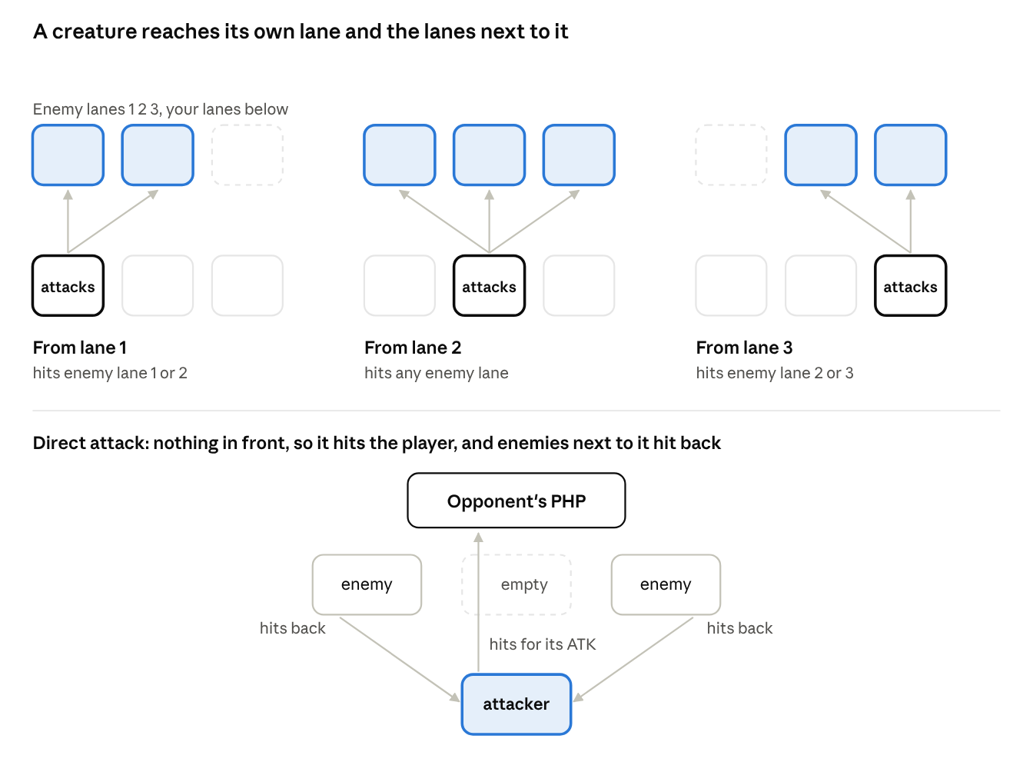
Who can hit what: 3 lanes
Attacking, step by step.
- In your Battle Phase, pick one of your creatures. Each creature can attack once per turn, one attack at a time.
- Choose its target: the enemy creature in front of it, or in a lane next to it. The middle lane reaches all three enemy lanes.
- Or attack the player. Only if nothing is in front of it. Enemy creatures in the lanes next to it hit it back with their ATK, unless they're winded.
- Response window. The defending player, then the attacking player, may play Instants. "When this creature attacks" effects trigger now, when the attack is declared.
- Resolve the fight using speed (below). The damage stays (section 12).
Nobody attacks on the first turn of the game. Creatures can't attack the turn they're played, and fusions can't attack the turn they're made. They still hit back when attacked.
Winded. A creature that attacks is winded until the start of your next turn. A winded creature can't hit back: not when it's attacked, and not when an enemy attacks you directly from a lane next to it. It still stands in its lane, so an enemy in front of it still can't attack you directly, and its effects still work. Attacking is a choice: the creature that hits now can't defend itself on your opponent's turn.

Speed
Speed runs from 1 to 4; 2 is normal.
- Attacker's advantage: the attacking creature gets +1 Speed for its attack.
- The faster creature deals its damage first.
- On a tie (after the +1), the attacker goes first.
- If the first hit destroys the other creature, it doesn't hit back.
- Direct attacks: enemies next to the attacker that are faster than it (counting its +1) hit it before it reaches the player. If they destroy it, the player takes nothing. Slower ones hit it after.
- Creatures with dice ATK roll for each attack and each hit back (section 15).
Fight | Speed | Result
Judicator Angel (4 ATK, 10 HP, Speed 4) attacks Carrion Duchess (3 ATK, 10 HP, Speed 2) | Judicator 4 + 1 = 5 vs Duchess 2: Judicator first | Duchess drops to 6/10 and hits back for 3. Judicator ends at 7/10.
Vein Ripper (4 ATK, 4 HP, Speed 3) attacks Cherub (1 ATK, 2 HP, Speed 3) | Vein Ripper 3 + 1 = 4 vs Cherub 3: Vein Ripper first | Cherub is destroyed and never hits back. Vein Ripper stays at 4/4.
Carrion Duchess (3 ATK, 10 HP, Speed 2) attacks Vein Ripper (4 ATK, 4 HP, Speed 3) | Duchess 2 + 1 = 3 vs Vein Ripper 3: a tie, so the attacker goes first | Duchess hits first: Vein Ripper drops to 1/4, then hits back for 4. Duchess ends at 6/10.
Judicator Angel attacks the player. In the lanes next to it: Pain Drinker (5 ATK, Speed 3) and Blood Imp (1 ATK, Speed 2) | Judicator 4 + 1 = 5 vs 3 and 2: Judicator first | The player takes 4. Then Judicator takes 5 + 1 and ends at 4/10.

14. Fusion
Fusions are the end goal: every fusion is built to be stronger than any creature you can materialize, and it frees up a lane.
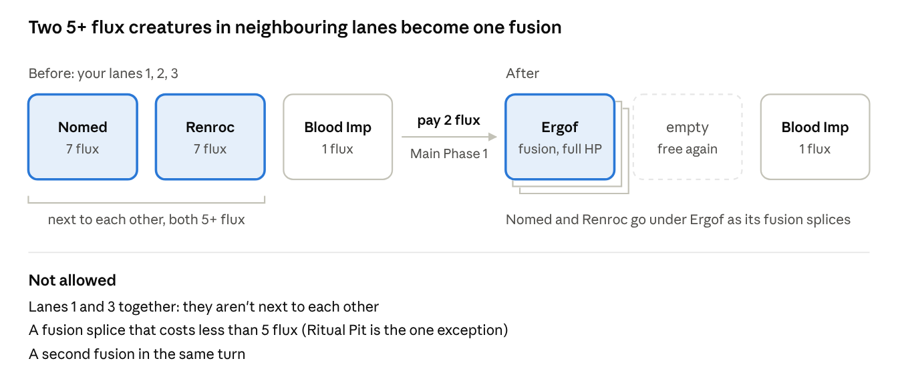
Fusing Ergof: before and after
How to fuse.
- Once per turn, in Main Phase 1, pay 2 flux.
- Choose 2 creatures you control in lanes next to each other, both with a printed cost of 5 or more flux.
- They must meet the recipe of a fusion in your Fusion Deck.
- Put both under the fusion card. They're its fusion splices now, not creatures.
- Put the fusion in either of their lanes. The other lane is free again.
The fusion arrives at its own printed stats and full HP. It has just arrived, so it can't attack until your next turn.
Ways around the 2 flux.
Card | Type | What it does
It's Free Fuse-Estate | Spell | Fuse without paying the 2 flux
Crimson Altar | Field Spell | Sacrifice another Unholy creature instead of paying the 2 flux

Using a cheaper fusion splice. Ritual Pit (Continuous Spell) is the one exception to the 5+ flux rule. Once per turn, banish an Unholy creature from your Waste Repository: your next fusion this turn may use an Unholy creature costing 3 or 4 flux as one of its fusion splices. You still pay the 2 flux to fuse.
Reading a recipe.
Recipe says | You need
{Nomed The Dark Viscount + Renroc The Dark Marquis} | Those exact two cards
{Chapel Guard + any Holy creature} | Chapel Guard, plus any creature with the Holy attribute
{any 2 Greedy creatures} | Any two creatures with the Greedy attribute

A creature with two matching attributes can fill either part: Hemogoblin is both Greedy and Unholy.
What carries over. Nothing. A fusion only has the effect printed on its own card. Its fusion splices' effects, stats, damage and stat changes don't carry over.
When a fusion leaves the field. If it's destroyed, the fusion card and its fusion splices go to your Waste Repository. Only the fusion's own death effects trigger; its fusion splices' death effects don't. If it leaves any other way (banished, say), the fusion card goes where the effect says and its fusion splices still go to your Waste Repository.
Mixing decks. Most recipes ask for an attribute rather than a specific card, so creatures from different decks can fuse together.

15. Keywords
Some cards carry a keyword that bends the rules.

Radiance
A creature with Radiance never wastes healing. When HP restored to it would go past its max HP, the extra becomes your choice of, until your next turn:
- that much +ATK, or
- that much +HP over its max (overhealth).
Its max HP doesn't change, and the bonus goes away at the start of your next turn.
Example: Holy Acolyte restores 2 HP to a Cherub at full HP (2/2). Cherub has Radiance, so you choose: +2 ATK, or 2 extra HP (4/2), until your next turn.
So +ATK helps it hit harder this turn, and +HP helps it survive your opponent's turn.

Blood Price
Some creatures say Pay 3 PHP per flux: Reduce this creature's flux cost by up to Y. When you materialize one from your hand, you can take any amount off its flux cost, up to Y, and pay 3 PHP for each flux you take off. A creature that can only drop 1 flux just says "Pay 3 PHP: Reduce this creature's flux cost by 1." Paying PHP is what lets you play them early.
Example: Vein Ripper costs 3 flux and says "Pay 3 PHP per flux: Reduce this creature's flux cost by up to 2." You can play it for 3 flux, for 2 flux and 3 PHP, or for 1 flux and 6 PHP.
The printed cost still counts for fusing: a creature printed at 5+ flux can fuse even if you paid less (section 14).

Dice ATK and Gold
Dice ATK. A creature's ATK can be a roll, like 1+d6. Roll it every time it attacks, for that attack only, and again whenever it hits back in a fight. "Natural 20" or "natural 1" means the die itself showed that number.
Gold. Everyone starts with 0 Gold and there's no cap. Only cards that mention Gold can make, spend or move it. Invested Gold is locked into that card: you can't take it back, and it's lost if the card leaves the field.

16. Advanced rules
The stuff you'll end up arguing about at 1am.
Forgotten effects. A forgotten optional effect ("may", or anything that helps you) is gone. A forgotten mandatory one is resolved if someone notices it the same turn; after that, let it go. Your opponent doesn't have to remind you, but being decent about it is encouraged.
Reading card text.
Card says | Means
"At the start / end of your turn" | Your own turn only
"Each turn", "every turn" | Both players' turns
"Until end of turn", "this turn" | Wears off at the end of the current End Phase
"Any creature", "a creature on the field" | Either side
"You control", "your field" | Your side only
"Enemy creature" | A creature your opponent controls
"Half of..." | Round down

Negate. A negated creature has no card text until the negation ends. Its stats, name and attributes stay, and anything it already did stays done.
Owner and controller. The owner is the player whose deck a card started in; the controller is whoever has it on their side now. A card going to a hand, deck, Waste Repository or Oblivion always goes to its owner's.
Hand limit. 8 cards, checked at the end of every turn. Discard the extra into your Waste Repository.
Searching your deck. Shuffle afterwards and offer your opponent the cut.
Once per turn / once per game. Counted per effect: 3 copies of the same card still get one use.
Targeting. An effect targets when it chooses a specific card. Attacking isn't targeting, so an untargetable creature can still be attacked.
Simultaneous effects. The player whose turn it is resolves theirs first, in the order they choose, then the other player.
Coin flips. Each player flips their own coin. No coin, no flips.

17. Quick reference
Starting PHP | 30. Restoring can't take you above 30; gaining can
Main Deck / Fusion Deck | 30 / up to 10, max 3 copies of a card
Opening hand | 5. One free redraw if it has 0 or 1 creatures; mulligan only if both players agree
Arriving | Creatures and fusions can't attack the turn they arrive
Draw per turn | 1 (the first player skips their first)
Flux | starts at 3, +1 a turn, max 10. Going second: +1 on your first turn
Reactor Phase | +1 max flux and refill. You may also Feed (a card to Oblivion: +1 flux this turn) or Skip (no +1, draw 1 extra card)
Lanes / spell zones / Field Spells | 3 / 3 / 1 per player
Attacks | each creature once per turn, own lane or the lanes next to it
Speed | 1-4, 2 is normal. The attacker gets +1, faster strikes first, the attacker wins ties
Winded | A creature that attacked can't hit back until your next turn
Fusing | once per turn, 2 flux, two 5+ flux creatures in neighbouring lanes
Empty deck | lose 5 PHP for each draw you can't make
Hand limit | 8
Gold | starts at 0, no cap

18. Glossary
Term | Meaning
Attribute | A tag like Holy, Unholy, Noble or Greedy. Does nothing on its own; matters when a card or recipe names it
Banish | Send a card to Oblivion. Not destroyed, so no death effects
Blood Price | A creature that lets you pay 3 PHP per flux to lower its flux cost (section 15)
Chain | A stack of responses, resolved newest first (section 11)
Continuous Spell | Stays in play and affects you (section 11)
Destroyed | At 0 HP or less, or destroyed by an effect. Goes to the Waste Repository. Same as dies or killed
Feed the reactor | In your Reactor Phase, send a card from your hand to Oblivion for +1 flux this turn (section 8)
Field Spell | Stays in play and affects everything on the field. 1 per player (section 11)
Flux | What you spend to materialize and fuse creatures (section 8)
Fusion | A creature made from 2 fusion splices, kept in your Fusion Deck until fused (section 14)
Fusion splice | A creature placed under a fusion card to make it
Gain PHP | Add PHP. Can take you above 30
Give HP | Permanently raise current and max HP
Gold | A resource some cards make and spend (section 15)
In front of | The enemy creature in the same lane, directly across
Lane | One of your 3 creature spots. Lane 2 is the middle
Lanes next to it | The lane(s) directly left and right. The middle lane has two, the outer lanes have one
Lose PHP | Any drop in PHP: damage, paying, or "lose X PHP"
Materialize | Put a creature onto the field, from your hand or by an effect (section 10)
Negate | Switch off a creature's card text (section 16)
Oblivion | Where banished cards and cards fed to the reactor go. They don't come back
PHP | Player Health Points. You start with 30
Radiance | A creature with Radiance turns healing past its max HP into +ATK or +HP until your next turn, your choice (section 15)
Restore HP | Heal up to max HP; max doesn't change
Restore PHP | Heal PHP, never above 30
Sacrifice | Destroy your own creature as a cost
Skip | In your Reactor Phase, don't raise your max flux and draw 1 extra card instead (section 8)
Speed | Decides who strikes first in a fight, 1 to 4. Attackers get +1 (section 13)
Target | When an effect chooses a specific card. Attacking isn't targeting
Waste Repository | Your face-up discard pile
Winded | A creature that attacked. It can't hit back until its controller's next turn (section 13)

19. Rulings
Answers to questions that come up in play.

Rules
- Feed: any card from your hand can feed the reactor. It goes face up to Oblivion. Feeding (or Overclock) can take you above 10 flux for that turn; max flux never goes above 10.
- Skip: you still make your normal draw. At 10 max flux, skipping costs you nothing.
- Winded ends at the start of its controller's next turn. A winded creature still blocks its lane and its effects still work.
- Arriving: a creature brought back by an effect (Lord Lazarus, Microwave, Carrion Duchess, Unfuse) has arrived, so it can't attack that turn.

Cards
- Space Squid: the creature moves to an empty lane on your side and can attack this turn. At the end of the turn it goes back to its old lane, or another empty one; with no empty lane it goes to its owner's Waste Repository. If you sacrifice it or use it as a fusion splice, it doesn't come back.
- Microwave: takes creatures, not fusions, from either player's Waste Repository. "When materialized" effects trigger.
- Unfuse: the fusion goes back to its owner's Fusion Deck. Its two fusion splices come back at full HP, one in the fusion's lane and one in an empty lane, each on its owner's side. With no empty lane, a splice goes to the Waste Repository. They don't count as materialized.
- Lord Lazarus: comes back once per game. Its fusion splices stay in the Waste Repository.
- Skinless Titan: only creatures it destroys in combat trigger its 2 damage.
- Goblin Pit Boss: its reroll is an activated effect, so only on your own turn. It can reroll any Greedy creature's die.
- Goblin Miner: once per turn counts per card name, so several Miners still pay for 1 flux per turn.
- Goblin Stock Broker: if nobody can look the price up, flip a coin.
- Market Research: if your deck has no Greedy creature, the gold is still paid.
- Loaded Dice: rerolls one die roll or coin flip, yours or your opponent's.
- Sanctuary Bells: heals Holy creatures on both sides. Radiance applies.
- Seraphim Wall and Sanctified Knight stack: a creature next to both takes 2 less combat damage.
- Orc: natural 20 and natural 1 only count on its own attacks, not when it hits back.
- Renroc, Ergof: "4 (or 6) or less HP" means current HP. Chapel Guard survives the first destroy effect too.
- Blood Imp: if your opponent controls a creature, you must pick a creature.

